**BASIC GEOMETRICAL IDEAS**

**GRADE-VI – WORKSHEET**

**I. Choose the correct answer.**

1. Two distinct points meet at a point is called __________ ( )
2. Parallel lines b) intersecting lines c) perpendicular lines d) None of these
3. How many lines can pass through 2 given points ( )
4. Many b)2 c) 3 d) 1
5. If a curve does not cross itself, then it is called __________ ( )
6. Simple curve b) open curve c) diagonal d) none of these
7. Which of the following is not a polygon. ( )
8. Square b) Triangle c) Rectangle d) Circle
9. Two lines perpendicular to the same line are ___________ ( )
10. Parallel b) Intersecting c) Concurrent d) None of these
11. **An angle is made up of two ………………. starting from common end point. ( )**(a) vertex  
    (b) lines  
    (c) rays  
    (d) line segments
12. **Assertion (A) – A line contains a countless number of points. ( )**

**Reason (R) – Line extends indefinitely in both directions.**

a) Both A and R are true and R is the correct explanation of A

b) Both A and R are true but R is not the correct explanation of A

c) A is true but R is false

d) A is false but R is true

**II. Answer the following Questions.**

1. Draw figures to show:  
   (a) Point M lies on the line PQ  
   (b) AB and CD intersect at P
2. 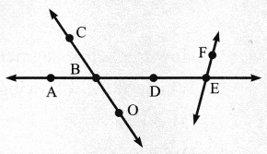Draw any triangles and locate:  
   (a) Point A in its interior  
   (b) Point B in its exterior  
   (c) Point C on it
3. 1. Use the figure to name:  
   (a) Line containing point E  
   (b) Line passing through A

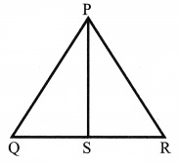(c) Line on which O lies  
(d) Two pairs of intersecting lines

4) (a) Identify three triangles in the figure  
 (b) Write the names of six line segments  
 (c) Which two triangles have Q as common?

1. Draw one open curve and one closed curve.
2. Match the following:

(a) Triangle (1) 4 sides

(b) Quadrilateral (2) 8 sides

(c) Heptagon     (3) 3 sides

(d) Pentagon     (4) 5 sides

(e) Octagon (5) 10 sides

(f) Hexagon (6) 6 sides

(7) 7 sides

**III. CASE STUDY:**

The students were asked to draw a closed figure with few points inside the figure, few points outside the figure and few on the boundary of the figure. One of the child drew a figure like this:

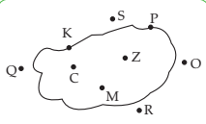

1. Where do points C, Z, M lie in the figure?
2. Which points lie in the exterior of the figure?
3. What kind of figure is it ?
4. Tick the open figures from the following

